|  |  |  |
| --- | --- | --- |
| **Guide Name** | | **Panel Head** |
|  | Dr.R Rajkamal | Dr.R Rajkamal |
|  |  |  |
|  | **Faculty Advisor** | **Project Domain** |
|  | Dr.P Madhavan | Machine Learning |
| M |  |  |
|  | **Student(s) Details: Name** | **Passport size photo(s)** |
|  | 1. Ambuj Porwal 2. Sajal Tyagi | 65449769007 (1) |
|  |  |  |

Registration Number(s)

1.RA1911003010236

2.RA1911003010238

**Email ID(s)&Mobile Number(s)**

|  |  |
| --- | --- |
| 1: ap1684@srmist.edu.in | 2: st8287@srmist.edu.in |
| 8433112578 | 7017151358 |

**Abstract Architecture Diagram**

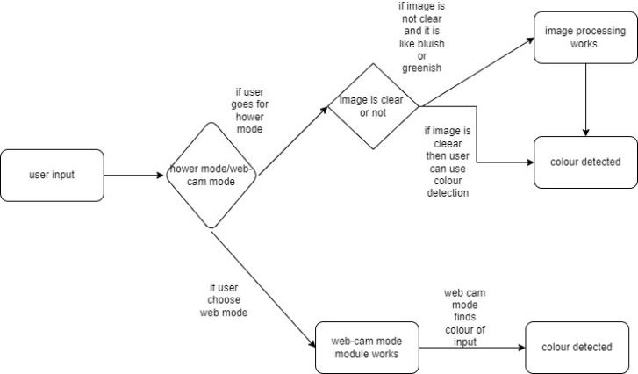

This paper shows implementation of Colour detection is the process of detecting name of the colour. Here this is easy task for humans to detect the colour and choose one.We are going to build an application through which you can automatically get the name of the color by clicking on them. So for this, we will have a data file that contains the color name and its values. Then we will calculate the distance from each color and find the shortest one.Which will be helpful for colour blind people a lot.

**Significance of the Project Conclusion**

This project is build to help the colour blind people because they cannot see the exact colour ,which cause lot of problems for them.

To ease their problem this whole project is dedicated.

We successfully created the way to find the colour, which is also divided into two different ways that is normal mode and live mode.And if the input image is not very clear(bluish or greenish) then it will clear the image as much it can and then it will detect colour.

**Conference/Journal Publication Details (If Any)**